**Multi-Criteria Decision Approach for a Sustainable Reverse Logistics Network under Fuzzy Environment**

|  |  |  |  |  |
| --- | --- | --- | --- | --- |
| **Study ID** | **indicators** | **methods** | **scale** | **practices** |
| ID58 | Three types of impacts are discussed: economic, ecological (carbon emissions) and social (optimal job opportunities, training).  Social sustainability is understood as the management of social resources: training for the workers, fixed jobs as well as inclusion of variable jobs based on the quantity of return)  The criteria in the Figure 2 could be considered for assessing the impact. | Multi-stage modeling:  Stage 1: hybrid method using Analytical Hierarchy  Process (AHP) and the Technique for Order Preference by  Similarity to Ideal Solutions (TOPSIS)  Stage 2: a three  objective mixed integer linear programming model is  developed in fuzzy environment which minimises the total  cost, the environmental impact and maximises the social impact of the network  utilising the weights of the objectives from the first stage | Weights of objective functions (alternatives) based on the  criteria requirements as shown in Fig 2 are determined. The weights  for alternatives are derived on the basis of numerous qualitative as well as  quantitative criteria. These weights are then used in TOPSIS  calculations and final weights for the objective functions  are derived. | AHP-TOPSIS Methodology |

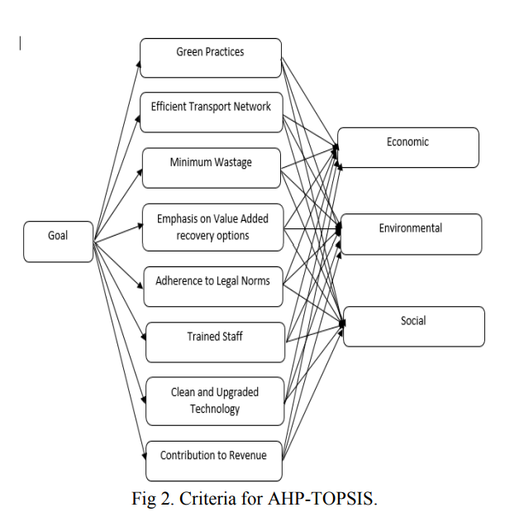

The paper presents a unifying perspective of sustainability by developing a framework of performance indicators for measuring reverse logistics performance based on the Triple Bottom Line approach. Three types of objectives or impacts are defined, namely economic, environmental and social. As the authors stated, qualitative and quantitative criteria were weighted in a two-stage model and objective functions were derived.